**DAILY ONLINE ACTIVITIES SUMMARY**

|  |  |  |  |  |
| --- | --- | --- | --- | --- |
| **Date:** | 12/07/2020 | **Name:** | JASLINE SHARON TAURO | |
| **Sem & Sec** | 4th sem,  A Section | **USN:** | 4AL18CS029 | |
| **Online Test Summary** | | | | |
| **Subject** | N/A | | | |
| **Max. Marks** | N/A | **Score** | N/A | |
| **Certification Course Summary** | | | | |
| **Course** | 1. [User Engagement](https://trailhead.salesforce.com/content/learn/modules/user-engagement) | | | |
| **Certificate Provider** | Sales Force | **Duration:** | | 3 hrs |
| **Coding Challenges** | | | | |
| **Problem Statement:**   Count of subsets with sum equal to X using Recursion | | | | |
| **Status:** | | Executed | | |
| **Uploaded the report in GitHub** | | YES | | |
| **If yes Repository name** | | <https://github.com/jaslinesharontauro/JAVA_Prgms> | | |
| **Uploaded the report in slack** | | YES | | |

**Certification Course Details:**

Today I started the new course “[User Engagement](https://trailhead.salesforce.com/content/learn/modules/user-engagement) ” by Sales Force. Today I learnt about how to **promote feature adoption and discovery and how to customize the troubleshooting. I have also successfully completed this course and have received a badge**.

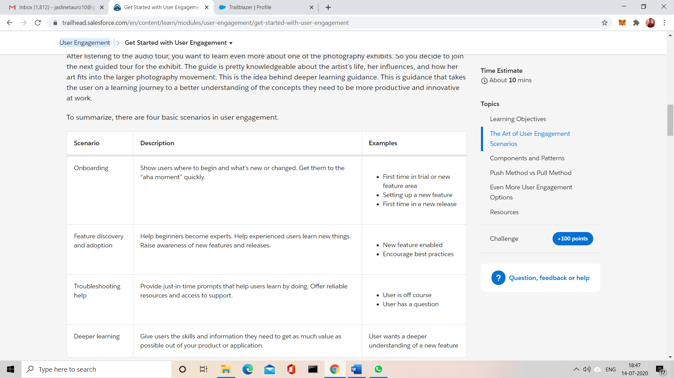

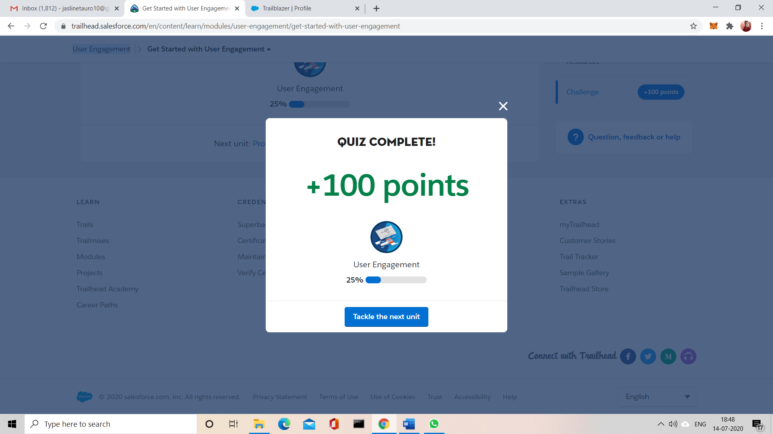

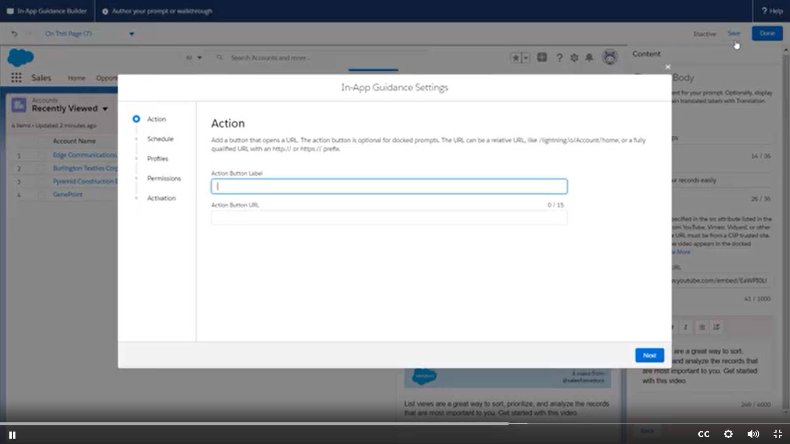

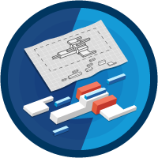

CODING CHALLENGES:

Problem Statement:

Count of subsets with sum equal to X using Recursion

Given an array arr[] of length N and an integer X, the task is to find the number of subsets with sum equal to X using recursion.

Examples:

Input: arr[] = {2, 3, 5, 6, 8, 10}, X = 10

Output: 3

Explanation:

All possible subsets with sum 10 are {2, 3, 5}, {2, 8}, {10}

Input: arr[] = {1, 2, 3, 4, 5}, X = 7

Output: 3

Explanation:

All possible subsets with sum 7 are {2, 5}, {3, 4}, {1, 2, 4}

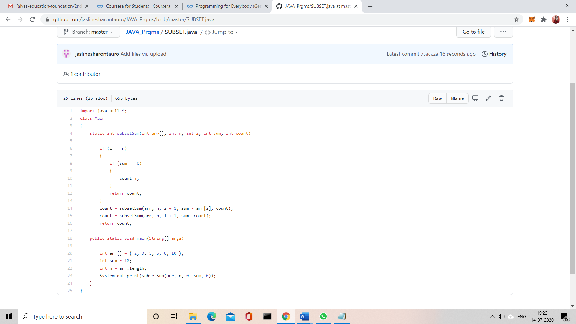

Solution uploaded in GitHub